WEEK 2 — Programming Languages, Frameworks & UI Components

1. Overview
Topic | Programming Languages, Frameworks & UI Development
Duration | Week 2 (3 Sessions)
Framework | Flutter (Dart)
IDE | Android Studio
Device | Xiaomi 24117RN76G — Android 16 (API 36)

2. Learning Objectives
No. | Objective
1 | Practice Dart syntax: variables, functions, loops, and classes
2 | Build common Flutter UI components (buttons, text fields, menus, cards)
3 | Implement multi-screen navigation using Navigator
4 | Apply form validation and user interaction feedback
5 | Build a complete Student Management mini-app

4. UI Components Built
Widget / Component | Where Used
Scaffold + AppBar | All 3 screens — base layout structure
TextField (with decoration) | Email, Password, Name, Student ID, Email fields
ElevatedButton | LOGIN and REGISTER action buttons
TextButton | Register link on Login screen
DropdownButtonFormField | Course selection on Register screen
Card / Container | Welcome card and student list items on Dashboard
CircleAvatar | Student initials avatar on Dashboard list
ListView.builder | Dynamic list of registered students
FloatingActionButton.extended | Add Student button on Dashboard
SnackBar | Success and error feedback messages
AlertDialog | Confirmation dialogs
BottomNavigationBar | UI showcase screen navigation
IconButton | Password visibility toggle and logout

5. App Architecture — Student Management App
Project file structure:

lib/
main.dart -- App entry point, MaterialApp setup
screens/
login_screen.dart -- Login form with validation
register_screen.dart -- Student registration form
dashboard_screen.dart -- Student list and stats
student_data.dart -- Shared data store (static list)

Screen navigation flow:
- main.dart → LoginScreen (app start)
- LoginScreen → DashboardScreen (on successful login)
- LoginScreen → RegisterScreen (via Register link)
- DashboardScreen → RegisterScreen (via + FAB button)
- DashboardScreen → LoginScreen (via logout icon)

6. Color Theme Applied — Orange & Black Dark Mode
Element | Color Applied
App background | Colors.black (#000000)
AppBar background | Colors.orange (#FF6D00)
AppBar text & icons | Colors.black (#000000)
Text field borders | Colors.orange (#FF6D00)
Text field fill | Color(0xFF1A1A1A) — dark grey
Buttons | Colors.orange with black text
Student avatars | Colors.orange with black initial
Accent / stats | Colors.amber (#FFD54F)
Card borders | Colors.orange with 30% opacity
Body text | Colors.white / Colors.white54

7. Screenshots
Screenshot 1 — Login Screen (Orange & Black theme):

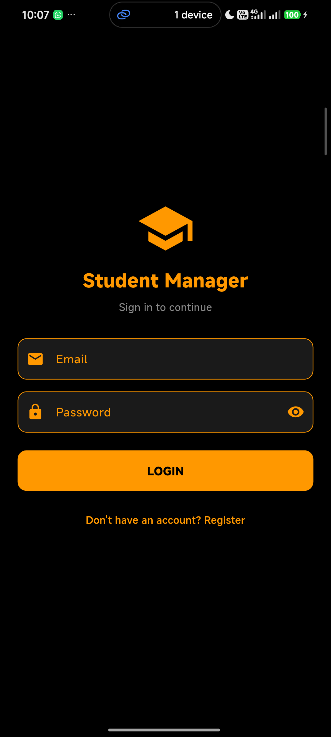

Screenshot 2 — Register Student Screen:

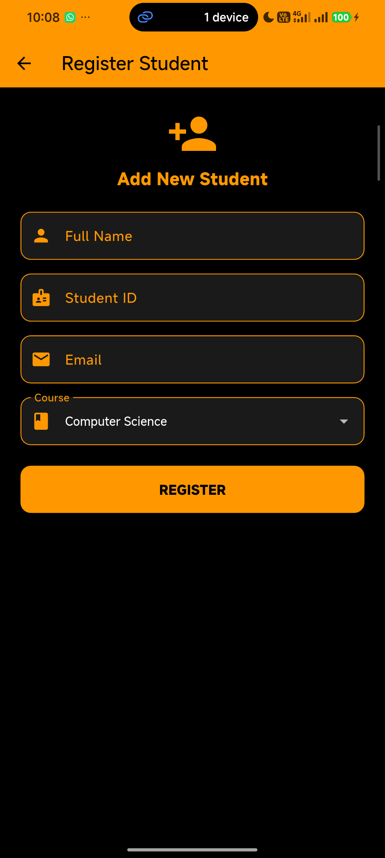

Screenshot 3 — Dashboard with student list:

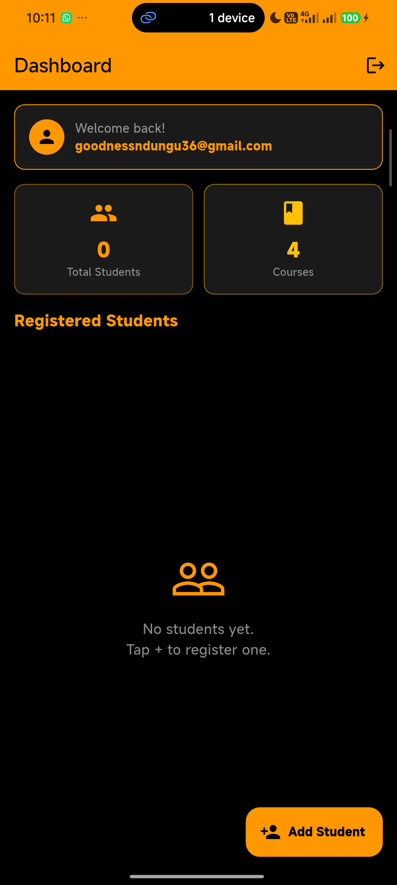

Screenshot 4 — Successful registration SnackBar:

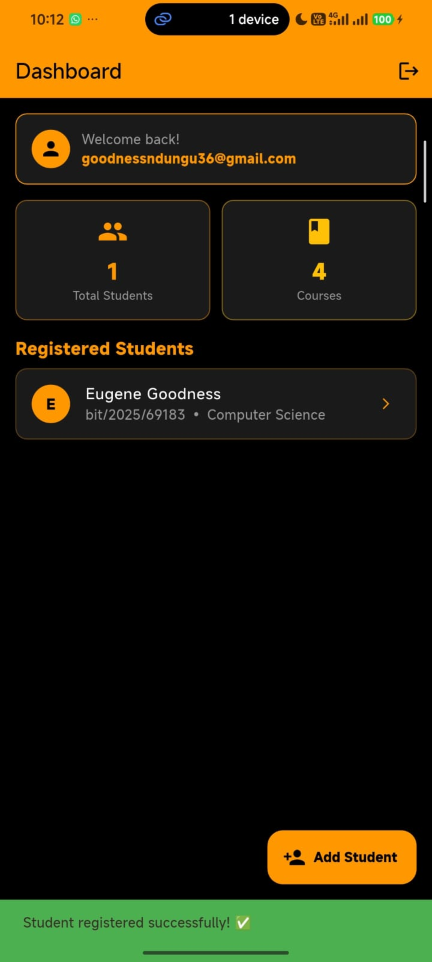

8. Challenges & Solutions
Challenge Faced | Solution Applied
Colors.black[50] error — operator [] not defined for Color | Replaced Colors.black[50] with Colors.black — black has no shade variants unlike Colors.blue[50]
Dashboard list not refreshing after adding student | Added setState(() {}) after Navigator.push returns so list re-renders with new data
Student data not shared between screens | Created StudentData class with static List so all screens access the same data
App showing on wrong device | Used flutter run -d 4tmju4dinbug4x8h to target the specific Xiaomi device ID

